**ICA Kenya**

**Bouncing back – watch this space**

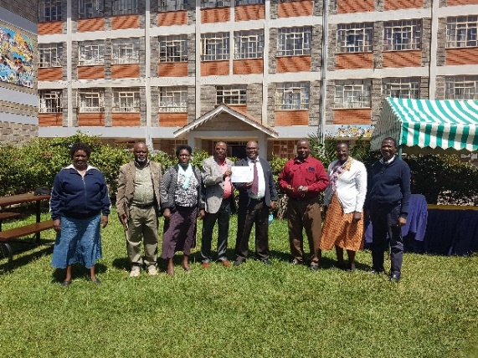Finally, ICA Kenya has been reinstated and in the picture is some of the staff who had gathered to receive team’s progress reports and celebrate the new certificate of registration. Among the staff are the two board members holding the certificate. ICAK is grateful to ICA – USA and ICA Japan for the support to realize this success.

While waiting for reinstatement, ICA Kenya developed a three-year participatory strategic plan (SP) and reviewed the first quarter and planned for the second quarter. Internal training on the use of zoom by the staff during virtual meetings was conducted successfully.

In the year 2019, an impact assessment of ICA methods was carried out in ilngwesi, Kamweleni, Kabiro, Kaloleni and Isinya. The methods were about strengthened relationships; build strong bonds and resilience which gave the communities the ability to effectively participate in their own development through the “Do Our Own Project” (DOOP) Model. It also enhanced community unity; networking among themselves and enabled people to gain access to available resources and services in order to solve problems together. In Ilngwesi it was about empowering the community to deal with the effects of HIV/AIDS and FGM with funding from ICA Canada. As a result of facilitating community capacity building programme the Mukogodo Girls Empowerment Programme (MGEP) was formed and currently operates as a Community Based Organisation (CBO). During the assessment, they identified the need to review their 2014 – 2018 strategic plan. In September 2021, MGEP contacted Patrick Mbullu of ICA Kenya to explore how best to progress this and a proposal to undertake a PSP process was jointly developed. Late in October 2021, MGEP requested ICA Kenya to run a 2.5-day planning exercise. The ICA Kenya team comprised of Henry Ikatukhu and Patrick Mbullu contacted the planning process using the Technology of Participation (ToP) methods to create a five-year strategic plan to address the question, “What must MGEP do by 2026 to successfully deliver on its mission of championing the rights of women and girls in Laikipia North?”

**PARTICIPATORY**

**STRATEGIC**

**PLAN**

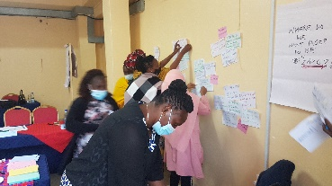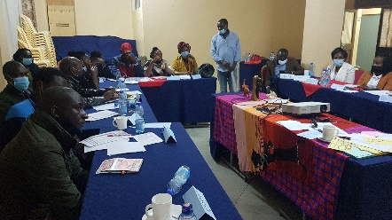To create the plan, 18 MGEP members and partners (board and supporters), met for two and half lively days at EMESS Hotel, Nanyuki Town. ICAK followed the classic ToP Strategic Planning sequence: practical vision, underlying contradictions, strategic directions and implementation (see diagram above). The partners’ vision captured the full range of MGEP core areas of focus: Education, Economic empowerment, Sexual & Reproductive health, Gender Based Violence, Mentorship, Drug & substance abuse that they must meet. What follows is the range of creativity that emerged from the participants. At the end of the event the participants appreciated the outcome.

ICA Kenya is in discussion with ICA USA on climate change project funding. It’s also in discussion with ICA Nepal alongside other Africa ICAs on Fundraising training and national capacity building to fundraise locally and internationally. The plans for CTL Training facilitated by ICA Canada is at advance stages. The training is set to start in February 2022 and it will take 5 months. The training will be mainly virtual and the participants will come from several ICA countries in Africa.

ICA Kenya is actively participating in regional and global virtual meetings.